**OSINT exercise #002 (Gralhix):**

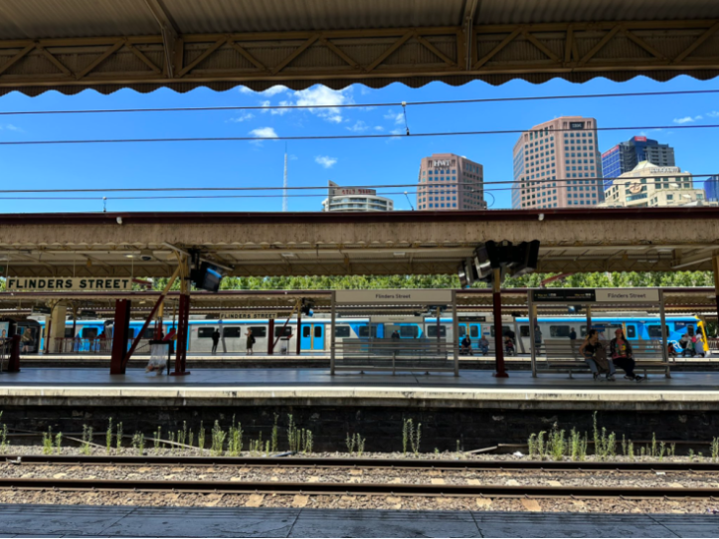

A number of signs in this picture show that the name of this train station is ‘Flinders Street’. A Google reverse image search shows a result from alamy of this train station and the same signs and even the same buildings in the background. The location is identified as Flinders Street Railway Station and a Google search shows that this station is located in Melbourne, Australia. Searching this location on Google maps, a number of 360-degree photos are available. Looking at some of these photos, I find one posted by Philip Baskerville in October 2017 that shows the exact same perspective, as well as the same buildings in the background.

I searched for this location in Google Earth Pro, where I changed the perspective to match the provided image. A number of structures can be seen, of which three seem potential highest buildings: the very narrow pointy structure on the left, the brown building next to the HWT building, and the black building on the right of that building. In Google Earth Pro, I am unable to quickly get identifying text from the narrow pointy structure, so I first look at the other two buildings. The brown building has the letters ‘IBM’, and the black building states ‘Central Equity’. Going back to Google maps, I indeed find a building tagged IBM Australia, and the second picture attached to this location shows exactly this building. I also find a building closeby tagged FOCUS Apartments by Central Equity. Clicking on this location shows a picture of this building where you can see the red part at the very top of the building, which can be seen in Google Earth Pro as well as the provided image. For the narrow pointy structure, I try to find the correct location in Google maps, and I quickly find it tagged as the Arts Centre Melbourne. In order to confirm which of these three buildings is the highest, I do a Google search for each of them, enquiring about their height. A search for ‘IBM Australia Melbourne building height’, gives a height of 131 meters. A search for ‘FOCUS Apartments Central Equity Melbourne building height’, gives a height of 166 meters. Lastly, a search for ‘Arts Centre Melbourne building height’, gives a height of 162 meters. In conclusion, the black building in this picture is the highest structure.